

(ISO 9001:2015 Certified), Accredited with ‘A’ Grade by NAAC

: 08258 - 281039 – 281263, Fax: 08258 – 281265

### Department of Computer Science and Engineering

B.E. CSE Program Accredited by NBA, New Delhi from 1-7-2018 to 30-6-2021

Report on Mini Project

STYLE STUDIO

#### Course Code : 18CSE41 Course Name : Web Programming

##### Semester: V SEM Section: A

**Submitted To:**

## Mr. Krishna Prasad N Rao Assistant Professor

## Department of Computer Science and Engineering

**Submitted By**

Blen Joswin Saldanha-4NM18CS039

Dhanush Raj-4NM18CS048

**Date of submission:**

16/12/2020

#### Signature of Course Instructor

# ABSTRACT

Salonshop is a necessity for almost everyone in their life. Nowadays, the business processes of this shops still use conventional methods. This method gives obstacles to customers who have a lot of activities, for example, they have to come directly to the beauty salon or barbershop to take the queue. In addition,even it is difficult for the shop owner to predict the number of customers he will receive on that day so that he can pre-plan for the challenges.

So we have designed a simple website for Seat Reservation System. With help of this website,the customers can book their seats online,and even it provides opportunity for the owner to view the customers who have booked,so that they can be well prepared.

It was an amazing opportunity for us to learn more interesting things about developing website.We hope that the knowledge we gain by this project will us in our future.

# TABLE OF CONTENTS

Title Page i

Abstract ii

Table of Contents iii

Introduction 4

Problem Statement 5

Objectives 6

Literature Review 7

Methodology 8

Implementation Details 10

Results 11

Conclusion and Future Scope 14

References 15

# INTRODUCTION

# 

We all wish to look handsome and beautiful.To achieve this ,Salon is good place to go

to a barbershop is a place where we style our hair, mustache,beard and also provide

massages that serves male customers.So it is place where lot of people visit daily.

Since there are lot of people involved,reserving a seat by traditional method consumes lot of time.It also makes lot of confusion among the customers about their turn of getting the service.

So we have developed simple website to reserve the seats online at time anywhere.

# PROBLEM STATEMENT

The majority of Salon Shops follow the traditional method of reserving seat.That is queue

system where the first person that visits the shop is provided the service first.If there are lot of customers who want to visit salon on the day, it becomes difficult for salon

owner to handle the situation.And also for the customers it is just a waste of time.

If owner follow the method for reserve the seat online,it beneficial for both customers and him.

So we as a software developers have developed as Website for Seat Reservation Online.

# OBJECTIVES

1]To Build User Friendly Website.

2]Admin To Monitor All The Input Data.

3]Protection of Data And Security of users.

4]To Provide Opportunity For Customers To Book online.

5]Easy Accessibility Of Data.

# LITERATURE REVIEW

1. https://bookedin.com -

This is a website to get appointment for clients and businesses to schedule appointments online .

1. https://www.urbancompany.com -

Urban Company was launched in November 2014. It is the largest home services platform in Asia, with presence in India, UAE, Singapore and Australia. The platform helps customers book reliable home services like beauty services, massage therapy, cleaning, plumbing, carpentry, appliance repair, painting etc. The company's vision is to empower millions of service professionals across the world to deliver services at home like never seen before. The company partners with tens of thousands of service professionals, helping them with with the training, credit, product procurement, insurance, technology and many other things.

# 

# METHODOLOGY

1.Operating System: Windows 64 bit

2.FRONT END:

* HTML
* CSS
* Javascript
* Bootstrap

BACK END:

* Mysql
* PHP

# IMPLEMENTATION

Our Website Contains:

1]Home Page : It has Navigation Bar to easily reach the content required for the use.

The home Page contains three buttons.These buttons are used for following purposes :

* Sign Up: In this page,customers sign up to create account to use the reservation service.
* Book Seat: In this page,customers with account can sign in and book their seats.
* Admin login: Admin can login and can view and delete the input data.

2]Features Page: This page contains all the features provided for the customers by the salon.

3]Service Page: This page contains all services provided by salon to the customers.

4]Feedback Page: This page contains the feedback about of some old satisfied customers.

5]Contact Us: Contains all the add info regarding address,phone number,email account, etc.

**RESULTS AND DISCUSSIONS**

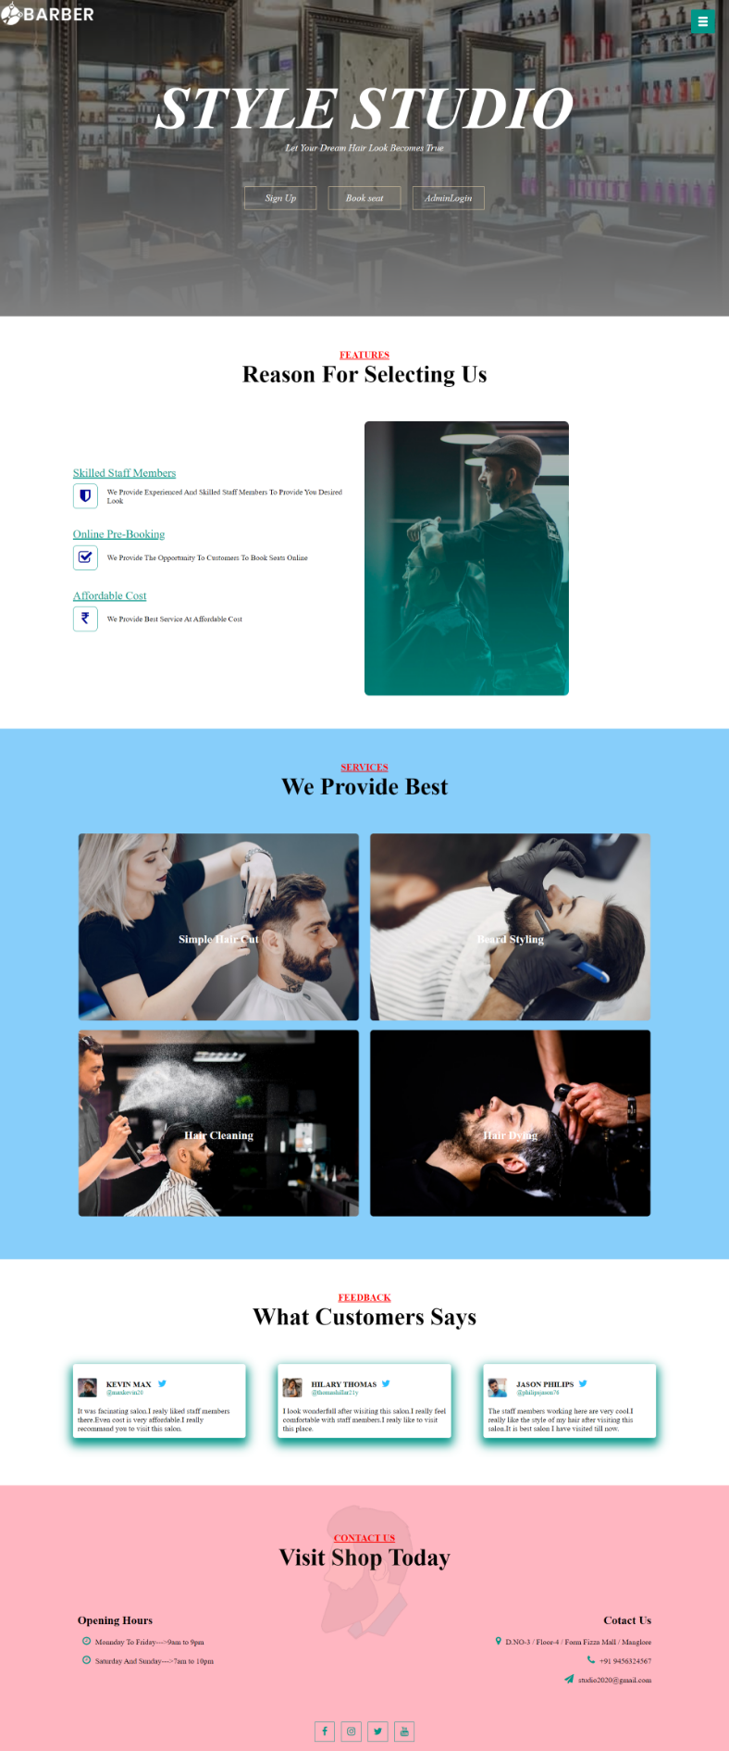s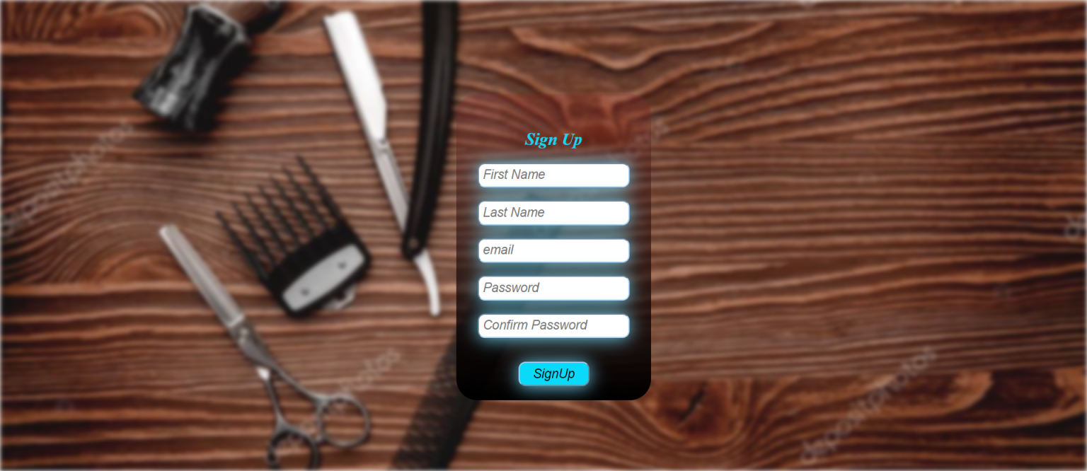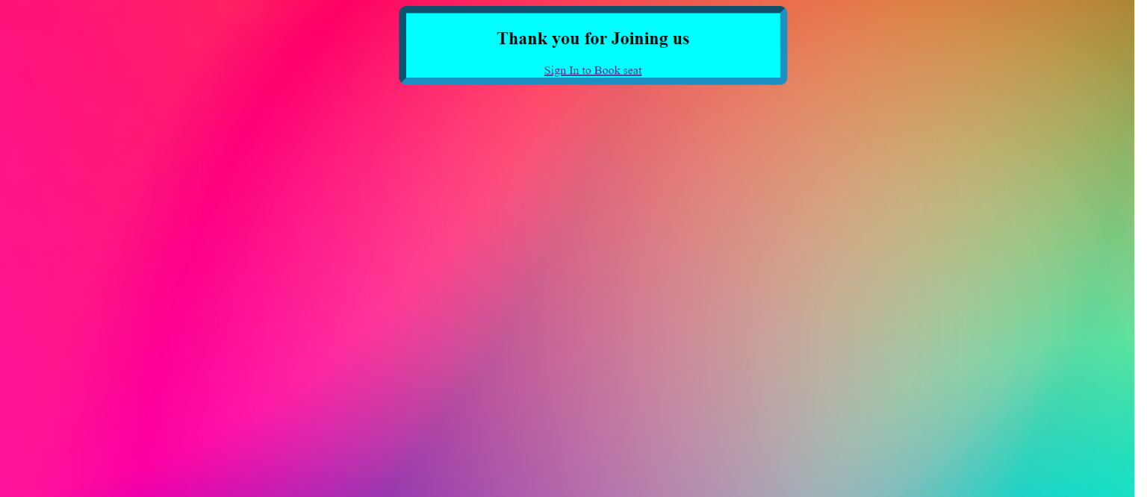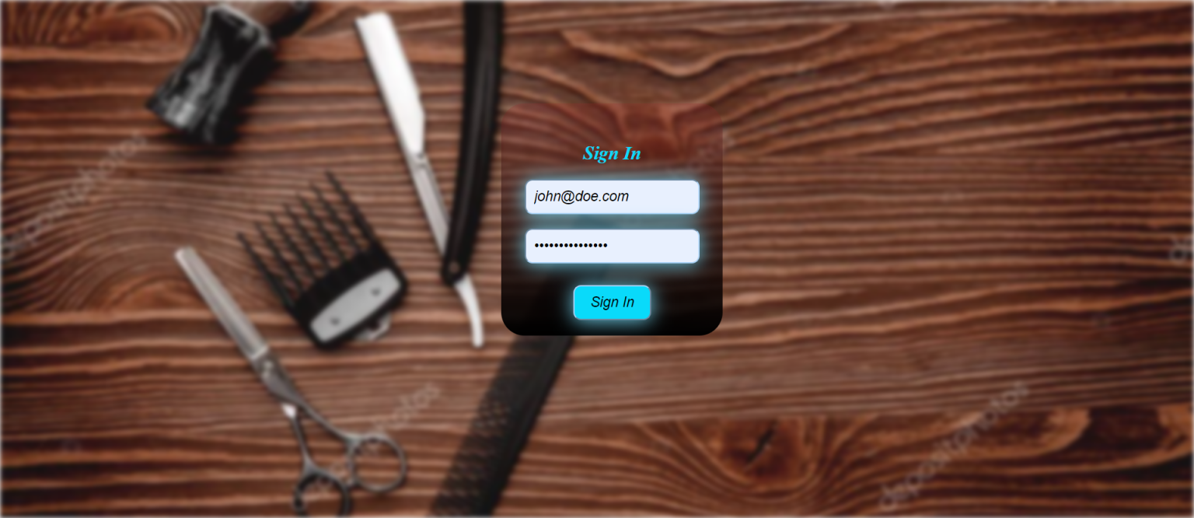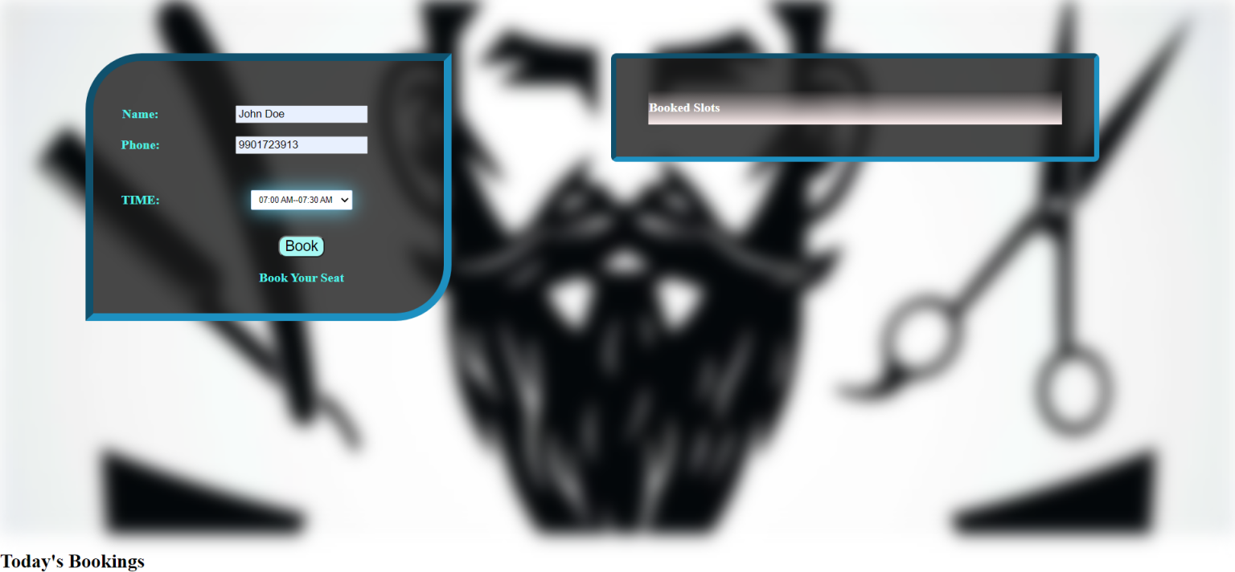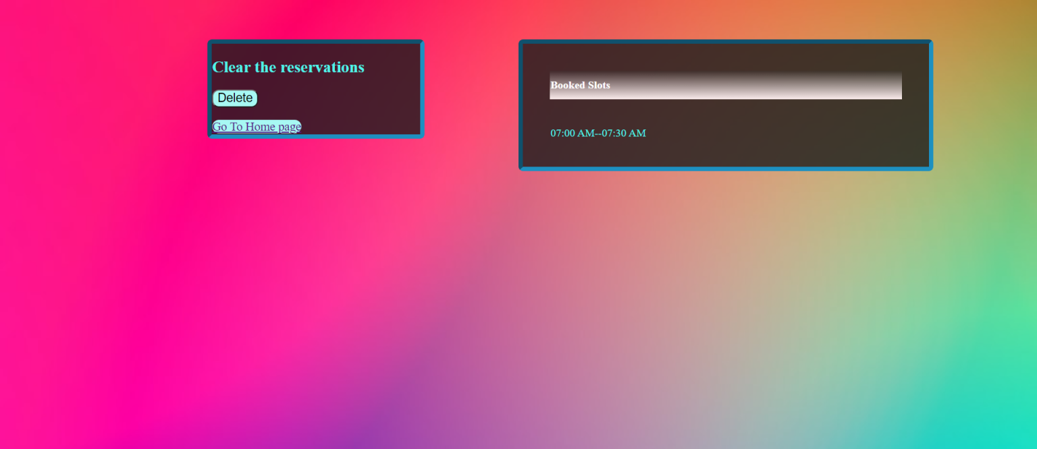

# CONCLUSION AND FUTURE SCOPE

This website contains all the basic information required for the user. But still we can do lot of extra features in the futures. Some of them are:

1]Provide opportunity for the admin to change his password whenever he needs.

2]Add Admin and delete admin.

3]Password Recovery.

4]Service Rating System.

----

# REFERENCES

1. **w3schools**
2. **Youtube**
3. **Bootstrap**